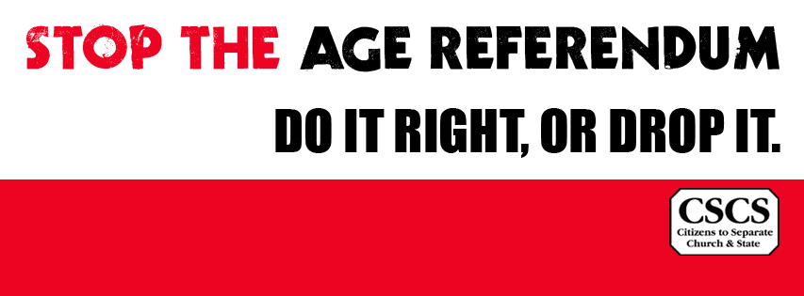

Citizens for Separation of Church and State
C/O
47, Sugarloaf Crescent,
Bray,
Co. Wicklow
cscsirl@gmail.com
24 February 2015

35th Amendment of Constitution Bill, 2015

Dear Taoiseach and cabinet members –
Citizens for Separation of Church and State (CCCS Irl) is a group of citizens who are concerned about the government’s proposed Thirty-fifth Amendment of the Constitution (Age of Eligibility for Election to the Office of President) Bill 2015 which is at the Order for Second Stage in the Oireachtas.
Our understanding is that the wording of the Bill does not contemplate the supplementation of the religious oath that a candidate-elect has to swear at the inauguration ceremony, with a parallel affirmation for those citizens who cannot, in conscience, swear an oath.
AND WHEREAS it is proposed to amend Article 12 of the Constitution for the purpose
of providing that the age of eligibility for election to the office of President shall be
twenty-one years instead of thirty-five years.
[http://www.oireachtas.ie/documents/bills28/bills/2015/615/b615d.pdf]

The requirement to swear a religious oath at installation is covered by Article No. 12.8:
The President shall enter upon his office by taking and subscribing publicly, in the presence of members of both Houses of the Oireachtas, of Judges of the Supreme Court and of the High Court, and other public personages, the following declaration:
"In the presence of Almighty God I do solemnly and sincerely promise and declare that I will maintain the Constitution of Ireland and uphold its laws, that I will fulfil my duties faithfully and conscientiously in accordance with the Constitution and the law, and that I will dedicate my abilities to the service and welfare of the people of Ireland. May God direct and sustain me."
We hope the government understands that the State has been under UN HRC scrutiny for decades over the fact that no alternate ‘affirmation’ is permitted under our Constitution [Article No. 12.8].
The All-Party Oireachtas Committee, which was established on 16 October
1997, also warned about the Oath requirement in its report on the ‘President’ (November 1998):
9 declaration upon entering office
The Constitution Review Group noted the UN Human Rights
Committee’s concern in their report on Ireland of August 1993
about the religious aspects of the President’s declaration under
Article 12.8: ‘The constitutional requirement that the President
and judges must take a religious oath excludes some people from
holding these offices’. Ireland ratified the UN International
Covenant on Civil and Political Rights on 8 December 1989 and
our laws must be in conformity with the principles laid down in
the covenant. In its second national report under the covenant to
the UN Human Rights Committee, the state, referring to the
Committee’s comment, pointed out that no practical problems had
arisen to date and that the All-Party Oireachtas Committee on the
Constitution was reviewing the matter because a change in the
declaration would require a constitutional amendment.
[http://archive.constitution.ie/reports/3rd-Report-President.pdf]

As recently as December 2011 Ireland affirmed to the UN Human Rights Council
Nineteenth session Report of the Working Group on the Universal
Periodic Review Ireland:
9.
Ireland emphasized that its commitment to human rights was based on the principle
that governments must always act with the intention of respecting the rights of the
individual and human dignity.
[http://daccess-dds-ny.un.org/doc/UNDOC/GEN/G11/175/20/PDF/G1117520.pdf?OpenElement]
We are at a loss to understand why the government is not addressing the human rights abnegation occasioned by the continuance of the discriminatory religious oath for holding high office.
We would consider it unethical if the import of the passing of the referendum was to extend the discriminatory oath to a new cohort and we urge you to not proceed with the referendum until such time as it is accompanied by one to insert the right to affirm upon taking high office.

Yours sincerely,

Dr. Mike McKillen and Dick Spicer

