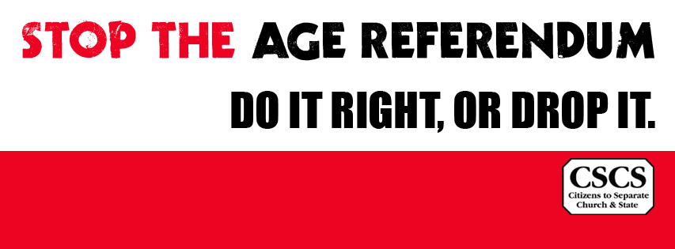

To: Leaders of faith bodies/religions in Ireland

24 February 2015

Re: 35th Amendment to Constitution

Citizens to Separate Church and State (CSCS) is seeking your faith body's support in its efforts to amend the government's proposed referendum dealing with the age for presidential election by adding a pluralist affirmation clause to our Constitution (Bunreacht na hÉireann) alongside the existing religious oath.
We feel that the forthcoming referendum to widen the age of eligibility for the office of President is the appropriate time to place this question before the people. However the government’s proposed Bill makes no attempt to deal with the religious oath to be made by the president-elect upon installation.
The requirement in the constitution at present is that the candidate elected as President takes a religious oath in order to assume office. [Article No. 12.8] This is the also case for appointments to the judiciary and the Council of State.
For many otherwise upstanding citizens, this religious oath conflicts with their consciences.
We are concerned that those seeking to take up such high offices are not given the choice to 'truthfully affirm', rather than swear that religious oath. We are asking that a 'truthfully affirm' (deimhním go fírinneach) clause be inserted to provide an alternative choice for those who do not espouse a religious viewpoint.
We seek your support in this matter, as this pluralist proposal aims to be as inclusive as possible.
It would allow those with religious beliefs to continue to swear by God, while giving the option to non-religious people and others to 'truthfully affirm'. The result of this would be to open up these high offices to a greater proportion of our population.
We believe that it is deeply unethical to impose a religious oath for any office of state on all citizens and the proposed Presidential age referendum extends this religious discrimination to a new cohort of citizens (i.e. the 21-35 year age range). We are trusting that you will accept the profound injustice inherent in this.
As one of the spiritual leader of an organisation concerned with the common good of Irish society we are hoping you will take a stand and ask that the referendum be stopped, unless the omission at installation to high office of a right to affirm is rectified. We urgently request a meeting with your good selves to make this appeal in person.
Yours sincerely
Dr Mike McKillen & Dick Spicer

